

**Capstone Project Report**

**GAS Store management System**

**GSMS**

**Report 3 – Software Requirement Specification**

**Team Member:**

|  |  |
| --- | --- |
| **Full Name** | **RollNumber** |
| Đào Văn Sơn | HE1604023 |
| Nguyễn Tuấn Cường | HE171665 |
| Trịnh Hoàng Dũng | HE170357 |
| Hoàng Minh Tuấn | HE171801 |
| Nguyễn Xuân Hậu | HE170950 |

– Hanoi, May 2023 –

**Table of Contents**

I. Project Report 3

1. Status Report 3

2. Team Involvements 3

3. Issues/Suggestions 3

II. System Requirement Specification 4

1. Overall Description 4

1.1 Product Overview 4

1.2 Business Rules 5

2. User Requirements 6

2.1 Overview 6

2.2 <<Feature Name 1 – i.e Order Meals>> 7

2.3 <<Feature name 2 – i.e: Meal Subscriptions>> 10

2.4 <<Next Feature Name..>> 11

3. Functional Requirements 12

3.1 System Functional Overview 12

3.2 <<Feature Name 1>> 14

3.3 <<Feature Name 2>> 14

4. Non-Functional Requirements 15

4.1 External Interfaces 15

4.2 Quality Attributes 16

5. Other Requirements 18

5.1 Appendix1 - Messages List 18

5.2 Appendix2 - … 18

5.3 … 18

# I. Project Report

## 1. Reversion History

|  |  |  |  |
| --- | --- | --- | --- |
| **Date** | **Description** | **Author** | **Comments** |
| 22/05/2023 | Version 0.1 | Group 4 | First Iteration |
| 01/06/2023 | Version 0.2 | Group 4 | Second Iteration |
| 27/06/2023 | Version 0.3 | Group 4 | Third Iteration |
| 13/07/2023 | Version 1.0 | Group 4 | Final relase |

## 2. Document Approval

|  |  |  |  |
| --- | --- | --- | --- |
| **Signature** | **Printed Name** | **Title** | **Date** |
|  | Đào Văn Sơn | Leader |  |
|  | Nguyễn Thành Ý | Instructor, SWP 391 |  |
|  |  |  |  |

# II. Software Requirement Specification

## 1. Overall Description

### 1.1 Product Overview

The GSMS(gas store management system) is an innovative software solution that aims to replace the existing manual and telephone-based processes for ordering gas and associated accessories. The provided context diagram outlines the external entities and system interfaces specifically for the initial release, known as version 1.0. It is important to note that the system is designed to evolve through subsequent releases, eventually integrating with internet-based ordering services for multiple local gas stores, as well as credit and debit card authorization services.

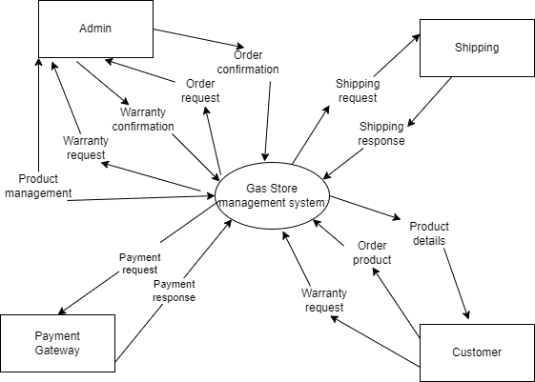

Figure 1.1: Context diagram

### 1.2 Purpose

The document on software requirements specifications was created to support the project of creating the GSMS (Gas Store Management System), which's main purpose is to provide an efficient way to manage and monitor gas stores.

The GSMS aims to streamline the operations of gas stores, simplifying inventory management, sales and billing processes, customer and supplier management, safety compliance, reporting, and analytics.

With the GSMS, gas store owners and employees can easily track and manage gas inventory, ensuring accurate stock levels, minimizing wastage, and promptly identifying expired or damaged items. The system facilitates seamless recording of gas sales, generating invoices or receipts for customers, and maintaining a transaction history for auditing purposes.

### 1.3 Scope

*This subsection should:*

The GSMS (gas store management system) will give people the help people find and access information of gas and related products at ease, giving them various payment methods including online and offline payment.

The system aims to automate manual processes, reducing the time and effort required for tasks such as inventory management and order processing.

### 1.4 Definitions, Acronyms, and Abbreviations

|  |  |
| --- | --- |
| SRS | Software Requirements Specifications |
| BR | Business Rule |
| UI | User Interface |
| N/A | Not applicable, not available |
| Use Case(s) | Diagram describe system requirements |
| GSMS | Gas store management system |

### 1.5 Business Rules

|  |  |
| --- | --- |
| ID | Rule Definition |
| BR-01 | Full name must be 1-50 characters and contain no special characters. |
| BR-02 | Users can only access information that belongs to them, except administrator. |
| BR-03 | Content manager only signs in with the account provided by the administrator. |
| BR-04 | Each user has exactly one role |
| BR-05 | Each email is only registered for an account |
| BR-06 | Email must be in the correct format: “abc123@gmail.com”. |
| BR-07 | Username must be unique |
| BR-08 | Username does not contain spaces and special characters |
| BR-09 | The length of the username must be between 4-20 characters |
| BR-10 | Password must be encrypted |
| BR-11 | Password length must be between 4-20 characters and contain no spaces |
| BR-12 | When changing the password, the user must enter the old password |
| BR-13 | Phone can only contain 10 digits and start with 0 |
| BR-14 | Date of birth must be before current time |
| BR-15 | All managed lists must be displayed with pagination |
| BR-16 | Fields marked with an asterisk (*) cannot be left blank |
| BR-17 | When reset the password, the user must enter the email so that system can send verify code |
| BR-18 | When register account, the user must enter the password twice |

## 2. General Description

### 2.1. Product perspective

The Gas Store Management System is a new, self-contained product designed to facilitate the efficient management of a gas store. It is not a replacement for any existing systems but serves as an independent solution to streamline operations within a gas store environment.

The Gas Store Management System can be considered as a component of a larger system, such as a retail management system, where it integrates with other modules and shares data. However, it can also function as a standalone system solely focused on gas store management.

The system encompasses various components and interfaces, both internal and external, that contribute to its functionality. Internally, the Gas Store Management System includes modules for inventory management, sales and billing, customer management, supplier management, and reporting. These modules work together to provide a comprehensive solution for gas store operations.

Externally, the Gas Store Management System may interface with external systems or services, such as payment gateways, fuel dispensers, accounting software, or customer loyalty programs. These interfaces allow seamless integration and data exchange between the Gas Store Management System and external entities, enhancing the overall functionality and efficiency of the system.

Overall, the Gas Store Management System is designed to provide an efficient and comprehensive solution for managing a gas store, optimizing inventory, streamlining sales processes, and enhancing customer and supplier management.

### 2.2 Product Functions

Customers:

1. Login: Users can login by username and password or Google account
2. Register: Users can login by filling in a form of personal information
3. Forgot password: Users can reset password if forgot by entering Gmail
4. Logout: Users can logout
5. Profile management: Account owner can view and change personal information of it (Address, name, phone number)
6. Blogs: Users can view articles about the company, company activities, market information. And comment to blogs
7. About us: Displays a description of the company, the supplier it works with, and the design team
8. Homepage: Users can view the products, product’s details, and search for products: price, supplier, category....... Users can also rate products - login required before rate
9. Cart: When the customers add products to the cart, the customer can easily view the product in the cart, and it is saved by session. Customers can also change quantity and delete products if they want.
10. Checkout: Require users to login before payment and allow users to review information. Display the form for the user to fill in the required attributes to be able to ship easily.

* Customers payment is done by e-commerce portal VNPAY

1. Orders management: Customers can easily track the progress of their orders, and when in a waiting state, customers can cancel their orders.
2. Order Detail: In the order detail table, the customer can view a warranty for his purchased product.
3. Messenger: Embed chat software on the website for customers to easily communicate with the admin about orders or product quality
4. Feedback: Users can send feedback about services and products to the Admin - there is a notification about mail
5. Products: Customers can see products details and logged in customers can reviews product by star rating and comments

Admins:

1. Dashboard:

* Show recently registered accounts
* View out for admin to see the results by data such as revenue, products sold, number of products
* Show the top 5 people who buy the most in the shop. Display graphs for admins can easily track better metrics with charts
* The chart shows the number of orders in the year
* Warn when a certain brand has too many products under warranty for a specified time

1. Order management: Allows tracking of orders, change the status of the product, has the right to refuse orders, and view every detail of each order
2. Account management: Allow to lock or unlock accounts. After changing the account status, send a notification email.
3. Blog management: Admin can write blogs, edit blog posts already written or in progress, view blogs according type, view blogs by months, and view blog details.
4. Manage feedbacks and reviews: Admins are allowed to view, hide, and unhide reviews and feedbacks.
5. Manager Supplier: Admin can add new supplier and lock or unlock supplier. Change information of supplier.

### 2.3 User Characteristics

The users are expected to have basic understanding of web browsing, and most of them have an online payment method

The users should have basic understanding of Vietnamese as the page will be shown in Vietnamese

The users shouldn’t have visual disability as interacting with the page require visual interactivity

### 2.4 General Constraints

Model-view controller was employed during coding

The Oracle Java code convention must be followed when writing code

Designed with Web Standard that uses HTML and CSS bootstrap 5

Methods/Functions are commented so developers can understand what they need to do later on

3. Specific Requirement  
Standard SEO principles:

* Display:
  + Responsive web design
  + Use a main colour throughout
  + Meet basic SEO standard: Google analytics, Favicon Icon, Heading (H1,..3)
* News management:
  + Display news such as:The company information, Main page banners.
  + Display news with support for picture or video
  + Product management
  + Display product by category
  + Display product detail
  + Allows downloading quotes in Excel and PDF format
* Customer support:
  + Embedding chat box into websites allows customers to interact directly with employees, with triggers installed
  + Add hotline and allows customers to call the Hotline number directly on the website
  + Add zalo into the website
* Main function:
* Areas of operation:
  + Supplying Gas, Gas stoves for households
  + Allows sales to be managed.
  + Create statistical reports of active customers, inactive customers and new customers.
  + Based on the statistical report above to send out special offers for different types of customers through email/sms.
  + Monitor the warranty for customer orders, make a report for orders that require attention, message the customer and give advice

## 4. User Requirements

### 4.1 Overview

#### a. Use Case Diagram

##### a.1. Customer

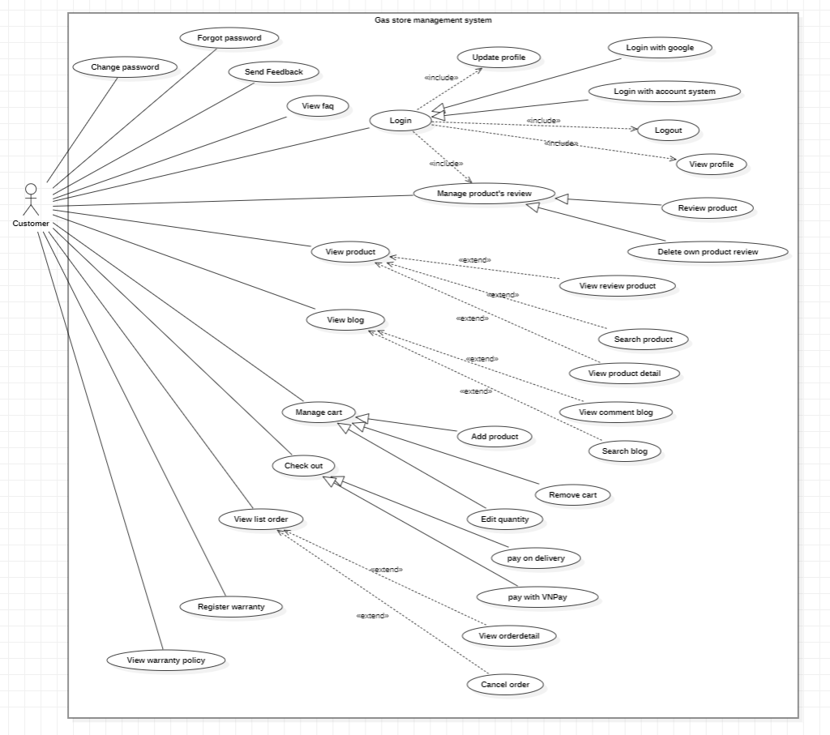

##### a.2 Admin

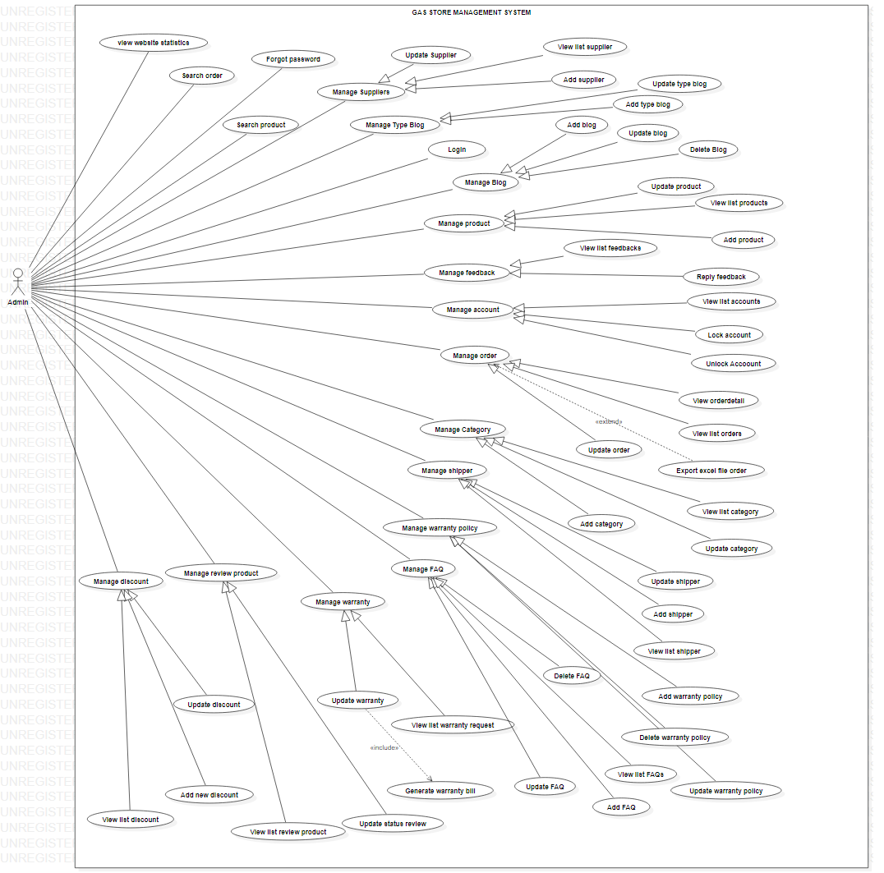

##### a.3 Guest

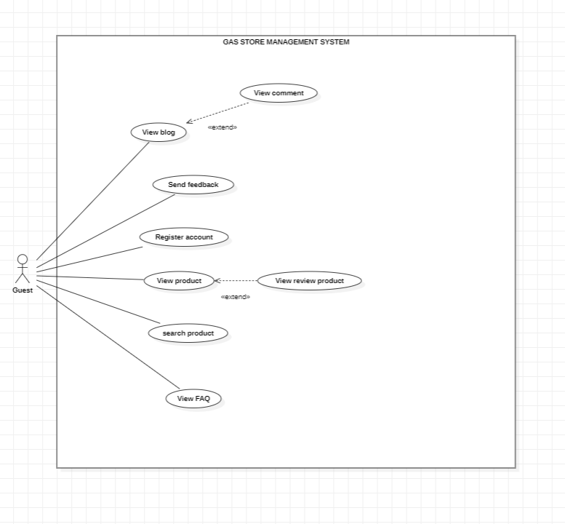

#### b. System Actors

|  |  |  |
| --- | --- | --- |
| **#** | **Actor** | **Description** |
| 1 | Administrator | Admin is the person who can manage the content on client site, all user of the system and their contents |
| 2 | Customer | Use system services such as order, view, search, payment. |
| 3 | Guest | Use the system to view product and login if they want to buy |

#### c. Use Cases List

|  |  |  |  |
| --- | --- | --- | --- |
| **ID** | **Use Case** | **Primary Actors** | **Secondary Actors** |
| 01 | View Menu | Patron |  |
| 02 | Order a Meal | Patron |  |
| 03 | Manage Meal Orders | Patron |  |
| 04 | Register for Payroll Deduction | Patron | Payroll System |
| 05 | Request Monthly Payments | [Auto] | Payroll System |
| 06 | Manage Meal Subscription | Patron |  |
| 07 | Manage Menu  *(View, Create, Modify, Delete, Archive)* | Administrator,  Menu Manager |  |
| 08 | Define a Meal Special | Menu Manager,  Cafeteria Staff |  |
| 09 | Handle Meal Orders | Cafeteria Staff |  |
| 10 | Prepare Meal | Cafeteria Staff |  |
| 11 | Request Meal Delivery | Cafeteria Staff |  |
| 12 | Record Meal Delivery | Deliverer |  |
| 13 | Print Delivery Instructions | Deliverer |  |
| 14 | Manage Users | Administrator |  |
| 15 | Login | [Guest] |  |

### 4.2 Register Account

|  |  |  |  |
| --- | --- | --- | --- |
| UC ID and Name: | UC – 4.2: Register Account | | |
| Created By: | SonDV | Date Created: | 27/05/2023 |
| Primary Actor: | Guest | Secondary Actors: | N/A |
| Trigger: | The Guest indicate that he want to create a new account. | | |
| Description: | The Guest would like to use more feature of this system and the first thing he must do is to use the Register function. | | |
| Preconditions: | 1. Access the website 2. Have no account 3. Have stable internet connection | | |
| Post-conditions: | 1. Create account successfully | | |
| Normal Flow: | 1. Visit the website 2. In upper-right corner, click on “Tài khoản”. 3. The system will show drop-down menu, click on “Đăng ký” 4. The system display register form 5. Input “UserName” 6. Input “FirstName” 7. Input “LastName” 8. Input “Email Address” 9. Input “Password” 10. Input “Confirm Password” 11. Click on “Register” 12. The system notify register successful and redirect to login page | | |
| Alternative Flows: | 1. Create account via login with google | | |
| Exceptions: | 1. Already have account 2. Username exist 3. Email Address exist | | |
| Priority: | High | | |
| Frequency of Use: | Usually | | |
| Business Rules: | BR-05, BR-06, BR-07, BR-08, BR-09, BR-10, BR-11, BR18 | | |
| Other Information: | N/A | | |
| Assumptions: | 1. Valid Input Data 2. Unique Email Address 3. No Duplicates | | |

### 4.3 Login

|  |  |  |  |
| --- | --- | --- | --- |
| UC ID and Name: | UC-4.3: Login | | |
| Created By: | SonDV | Date Created: | 27/05/2023 |
| Primary Actor: | Customer | Other  Actors: | N/A |
| Trigger: | Click on the login button in the header of the website interface or the system redirect you to the login page | | |
| Description: | The actor logs into the system to use system functions | | |
| Preconditions: | After register account | | |
| Postconditions: | Actor have login to the system | | |
| Normal Flow: | 1. Select login 2. Software: Display Login screen with the following fields: User name, Password, Login button, Close button 3. Actor enter username and password then click login button 4. Software: Validate username and password | | |
| Alternative Flows: | N/A | | |
| Exceptions: | 4a. Error message: Required fields need to be entered if the customer is missing  4b. Error message: Invalid email and/or password if the email and password are not found in the system | | |
| Priority: | Normal | | |
| Frequency of Use: | Usually | | |
| Business Rules: | N/A | | |
| Other Information: | N/A | | |
| Assumptions: | N/A | | |

### Forgot Password

|  |  |  |  |
| --- | --- | --- | --- |
| UC ID and Name: | UC-4.4: Forgot password | | |
| Created By: | SonDV | Date Created: | 27/05/2023 |
| Primary Actor: | Customer, Admin | Secondary  Actors: | N/A |
| Trigger: | User clicks on the Forgot password button on the Login screen. | | |
| Description: | User will redirect to the Forgot password page to get a new password. | | |
| Preconditions: | User access the website  Actor account is active | | |
| Postconditions: | When the normal flow completes successfully, User will have a new password. | | |
| Normal Flow: | 1. System: Display Forgot password screen with the field Email.  2. User enters the email into the Forgot password screen.  [Exception 2a]  3. System: Validate the entered email, Send an email to the actor email with the OTP and redirect to the Enter OTP page.  [Exception 3a]  4. User enter the OTP into the Enter OTPpage.  [Exception 4a, 4b]  5. System: Redirect to Enter new Password page.  6. User enter new Password and re-entered password.  [Exception 6a]  7. System: Check if the re-entered password and the password are the same, check if the password is enough level of security.  [Exception 7a, 7b] | | |
| Alternative Flows: | N/A | | |
| Exceptions: | 2a/4a/6a. Error message: Required fields need to be entered if the customer is missing.  3a. Error message: Invalid email if the email is not found in the system.  4b. Error message: Wrong OTP.  7a. Error Message: Confirmation password does not match Password if the two passwords do not match.  7b. Error message: Password needs to be secure if the password does not guarantee the security attributed specified  by the system (with at least 8 characters). | | |
| Priority: | Normal | | |
| Frequency of Use: | Usually | | |
| Business Rules: | N/A | | |
| Other Information: | N/A | | |
| Assumptions: | N/A | | |

### Logout

|  |  |  |  |
| --- | --- | --- | --- |
| UC ID and Name: | UC-4.5: Logout | | |
| Created By: | SonDV | Date Created: | 27/05/2023 |
| Primary Actor: | Customer | Other  Actors: | Admin |
| Trigger: | The user(customer/admin) indicates that he/she wants to stop access of one machine to an account | | |
| Description: | The user(customer/admin) want to login with another account | | |
| Preconditions: | The user has logged into the system | | |
| Postconditions: | The login session is discarded  The user becomes a guest with limited actions | | |
| Normal Flow: | Actor click on Logout in the home page | | |
| Alternative Flows: | N/A | | |
| Exceptions: | N/A | | |
| Priority: | Medium | | |
| Frequency of Use: | 100 times a day | | |
| Business Rules: | N/A | | |
| Other Information: | N/A | | |
| Assumptions: | N/A | | |

### Update Profile

|  |  |  |  |
| --- | --- | --- | --- |
| UC ID and Name: | UC-4.6: Update profile | | |
| Created By: | SonDV | Date Created: | 27/05/2023 |
| Primary Actor: | Customer, Admin | Other Actors: | N/A |
| Trigger: | Click on “Tài khoản” on the header | | |
| Description: | User can view and change their profile information. | | |
| Preconditions: | User have logged in | | |
| Postconditions: | User can change and view profile information | | |
| Normal Flow: | 1.  System: Display profile information and fields to edit.  2.  User: Edit profile information.  [Exception 2a,2b]  3. User: presses update to save the details. | | |
| Alternative Flows: | N/A | | |
| Exceptions: | 2a. Error message: Required every field to be entered.  2b. Error message: Email must follow the format a@gmail.com. | | |
| Priority: | Normal | | |
| Frequency of Use: | Usually | | |
| Business Rules: | N/A | | |
| Other Information: | N/A | | |
| Assumptions: | N/A | | |

### Change Password

|  |  |  |  |
| --- | --- | --- | --- |
| UC ID and Name: | UC-4.7: Change password | | |
| Created By: | SonDV | Date Created: | 27/05/2023 |
| Primary Actor: | Customer, Admin | Other Actors: | N/A |
| Trigger: | Click on “Đổi mật khẩu” in account details on home page | | |
| Description: | User change their password | | |
| Preconditions: | User have logged in | | |
| Postconditions: | When the normal flow completes successfully, User will have a new password | | |
| Normal Flow: | 1. System: Display change password page with new password and confirm new password as required fields.  2. User enter all the required fields and click the button “Lưu”.  [Exception 2a, 2b]  3. System: Update the user password. | | |
| Alternative Flows: | N/A | | |
| Exceptions: | 2a. Error Message: confirm new password does not match new password if the two passwords do not match.  2b. Error message: Password needs to be secure if the password does not guarantee the security attribute specified by the system (with at least 8 characters). | | |
| Priority: | Normal | | |
| Frequency of Use: | Usually | | |
| Business Rules: | N/A | | |
| Other Information: | N/A | | |
| Assumptions: | N/A | | |

### 4.8 Manage Order

### 4.9 Manage Accounts

|  |  |  |  |
| --- | --- | --- | --- |
| UC ID and Name: | UC-4.9: Manage accounts | | |
| Created By: | SonDV | Date Created: | 27/05/2023 |
| Primary Actor: | Admin | Other  Actors: | N/A |
| Trigger: | Click on the “Người dùng” buttons in the menu in the website | | |
| Description: | The actor can manage customers’s accounts | | |
| Preconditions: | Actors must have logged in as admin | | |
| Postconditions: | The actor can change accounts’s active status, see accounts’s infos such as name, phone numbers and orders | | |
| Normal Flow: | Click on the profile button in the top 5 buyers list. Or click on the user's tab in the left menu panel and click on the user's profiles Click on active status options, and a pop-up will appear. Press ok to confirm | | |
| Alternative Flows: | N/A | | |
| Exceptions: | 6a. System Error Message: Required fields to enter if the customer is missing  7a. System Error Message: Invalid email address if only invalid email  8a. System Error Message: Confirmation password does not match Password if the two passwords do not match  9a. System Error message: Password needs to be secure if the password does not guarantee the security attributed specified by the system (with at least 8 characters) | | |
| Priority: | High | | |
| Frequency of Use: | Sometimes | | |
| Business Rules: | N/A | | |
| Other Information: | N/A | | |
| Assumptions: | N/A | | |

### 4.10 Manage Supplier

|  |  |  |  |
| --- | --- | --- | --- |
| UC ID and Name: | UC-4.10: Manage supplier | | |
| Created By: | TuanHM | Date Created: | 24/05/2023 |
| Primary Actor: | Admin | Secondary Actors: | Customer, Guest |
| Trigger: | User click on the “Thương hiệu” buttons in the menu in the website | | |
| Description: | User can manage supplier | | |
| Preconditions: | User must have logged in as admin | | |
| Postconditions: | User can see supplier's info, add, delete, edit them | | |
| Normal Flow: | 1. System displays a list of all suppliers, their properties and a form User can fill in to add more suppliers.  2. User fill in the form and click “Thêm”.  [Exception 2a, 2b] [Alternative 2a]  3. System add the supplier.  [Exception 3a] | | |
| Alternative Flows: | 2a. User click on “Hồ sơ” of a supplier.  3a. System display a form with that supplier information  4a. User edit the form and click “Done”.  [Exception 2a, 2b]  5a. System update the supplier. | | |
| Exceptions: | 2a. System Error Message: Required to enter if the fields is missing.     2b.input must follow the right format     3a. System Error Message: Information of a new supplier must be different from other suppliers. | | |
| Priority: | Normal | | |
| Frequency of Use: | Sometimes | | |
| Business Rules: | N/A | | |
| Other Information: | N/A | | |
| Assumptions: | N/A | | |

### 4.11 View Cart

|  |  |  |  |
| --- | --- | --- | --- |
| UC ID and Name: | Cart | | |
| Created By: | DungTH | Date Created: | 27/05/2023 |
| Primary Actor: | Customer | Other  Actors: | N/A |
| Trigger: | Click on the “Giỏ hàng” button in the website | | |
| Description: | The actor can view and adjust the items added to the cart | | |
| Preconditions: | After the actor added thing to the cart | | |
| Postconditions: | The actor can view, change the quantity or remove the items added to the cart | | |
| Normal Flow: | 1. Click “Giỏ hàng”   [1a]   1. Software: Display the following:    * A table that display the following attribute of the item: image, name, quantity, discount, unit price, total price and a button to remove the item    * The total price of every item in the cart    * A button to go to check out | | |
| Alternative Flows: | 1. Click “Thêm vào giỏ hàng” 2. Software: Add the item to the shopping cart 3. Click on the Cart(header) function 4. Software: Display the following:  * The item with it’s picture, price, quantity and a button to remove the item from the cart * The total price for all the items * A button to go to the Cart(page) * A button to go to check out | | |
| Exceptions: | When add or update new suppliers:   * Every field cannot be left empty * For add, infos cannot be duplicated * Emails’s input must follow the right format | | |
| Priority: | Normal | | |
| Frequency of Use: | Usually | | |
| Business Rules: | N/A | | |
| Other Information: | N/A | | |
| Assumptions: | N/A | | |

### 4.12 Manage Product’s Reviews

|  |  |  |  |
| --- | --- | --- | --- |
| UC ID and Name: | UC-4.12: Manage products’s reviews | | |
| Created By: | SonDV | Date Created: | 27/05/2023 |
| Primary Actor: | Admin | Secondary  Actors: | Customer |
| Trigger: | User click on the “Review” button in the menu in the website | | |
| Description: | User can manage reviews | | |
| Preconditions: | User must have logged in as admin | | |
| Postconditions: | User can see and answer reviews and hide inappropriate ones. | | |
| Normal Flow: | Viết lại | | |
| Alternative Flows: | N/A | | |
| Exceptions: | Viết lại | | |
| Priority: | Normal | | |
| Frequency of Use: | Usually | | |
| Business Rules: | N/A | | |
| Other Information: | N/A | | |
| Assumptions: | N/A | | |

### 4.13 Manage Feedbacks

|  |  |  |  |
| --- | --- | --- | --- |
| UC ID and Name: | UC-4.13: Manage feedbacks | | |
| Created By: | DungTH | Date Created: | 27/05/2023 |
| Primary Actor: | Admin | Other  Actors: | N/A |
| Trigger: | Click on the “Feedback” button on the sidebar | | |
| Description: | The actor can reply and manage the feedback from the customer | | |
| Preconditions: | After the actor gain access to the admin page | | |
| Postconditions: | The actor can reply reply and manage the feedback from the customer | | |
| Normal Flow: | 1. Click “Feedback” 2. Software: Display the following:  * Feedback from the customer * A “Reply” button * A “Detail” button  1. Click the “Reply” or the “Detail” button 2. Software: Show a chat box to reply to the customer 3. Reply to the customer 4. Software: Send the customer an email of the reply and blank out the “Reply” button | | |
| Alternative Flows: | N/A | | |
| Exceptions: | 6a. The email fail to send | | |
| Priority: | Normal | | |
| Frequency of Use: | Usually | | |
| Business Rules: | N/A | | |
| Other Information: | N/A | | |
| Assumptions: | N/A | | |

### 4.14 Search Product

|  |  |  |  |
| --- | --- | --- | --- |
| UC ID and Name: | UC-4.14: Search product | | |
| Created By: | HauNX | Date Created: | 24/05/2023 |
| Primary Actor: | Admin | Secondary Actors: |  |
| Trigger: | Actor logins to system with account  Actor clicks button search product | | |
| Description: | The actors can search the blogs | | |
| Preconditions: | 1. Actor have account with role admin  2. Device need connected internet | | |
| Post-conditions: | The systems display all the products matching the searching | | |
| Normal Flow: | 1. Actor clicks on the products list in the left menu  2. The systems displays all the products  3. Actor fills data to the form  4. Actor clicks button “Tìm kiếm”  5. The system shows the actor all products that match the searching. | | |
| Alternative Flows: | N/A | | |
| Exceptions: | N/A | | |
| Priority: | Low | | |
| Frequency of Use: | Normal | | |
| Business Rules: | N/A | | |
| Other Information: | N/A | | |
| Assumptions: | N/A | | |

### 4.15 Send Feedback

|  |  |  |  |
| --- | --- | --- | --- |
| UC ID and Name: | UC-4.15: Send Feedback | | |
| Created By: | SonDV |  |  |
| Primary Actor: | Customer, Guest |  |  |
| Trigger: | User click on “Liên hệ” on the navbar and the system will redirect to the contact. | | |
| Description: | Users send feedback to admins about services, products, and accounts. | | |
| Preconditions: | User access the website. | | |
| Postconditions: | User have created feedback. | | |
| Normal Flow: | 1. System display form sends feedback.  2. Users  fill out all form information and click on “Send”.  [Exception 2a]  3. System submit and send email alert to user. | | |
| Alternative Flows: | N/A | | |
| Exceptions: | 2a: System Error Message: Required to enter if the fields is missing | | |
| Priority: | Normal | | |
| Frequency of Use: | Occasionally | | |
| Business Rules: | N/A | | |
| Other Information: | N/A | | |
| Assumptions: | N/A | | |

### 4.16 Create Product

|  |  |  |  |
| --- | --- | --- | --- |
| UC ID and Name: | UC-4.16: Create prodcut | | |
| Created By: | HauNX | Date Created: | 24/05/2023 |
| Primary Actor: | Admin | Secondary Actors: |  |
| Trigger: | Actor logins to system with admin role  Actor clicks on the create button in the blog management page | | |
| Description: | The actors can create a product | | |
| Preconditions: | 1. Actor has account with role admin  2. Device need connected internet | | |
| Post-conditions: | The systems create  a product and records in the database | | |
| Normal Flow: | 1. Actor clicks on the prodcut list in the left menu  2. The systems displays all the products  3. Actor chooses a product and clicks on create item  4. The system displays a form to create  5. The actor fills in the form and clicks create.  6. The product is created and recoreded in the database | | |
| Alternative Flows: | N/A | | |
| Exceptions: | N/A | | |
| Priority: | Low | | |
| Frequency of Use: | Normal | | |
| Business Rules: | N/A | | |
| Other Information: | N/A | | |
| Assumptions: | N/A | | |

### 4.17 Manage Shippers

|  |  |  |  |
| --- | --- | --- | --- |
| UC ID and Name: | UC-4.17: Manage shipper | | |
| Created By: | TuanHM | Date Created: | 27/05/2023 |
| Primary Actor: | Admin | Other  Actors: |  |
| Trigger: | The admin want to add, change shipper active status | | |
| Description: | The admin would like the shipper to be under admin’s control | | |
| Preconditions: | The user must have logged in as admin | | |
| Postconditions: | Shipper’s data changes | | |
| Normal Flow: | 1.      Click on Shipper in “Thêm mới” menu in admins index site  2.      Enter shipper infos and click add or click change/delete on the Shipper list | | |
| Alternative Flows: | N/A | | |
| Exceptions: | 1.      Data field must not left blank  2.      Data must not be duplicated with those that’s already exist | | |
| Priority: | Medium | | |
| Frequency of Use: | 5 times a week | | |
| Business Rules: | Data fields must not left blank  Data must not be duplicated with those that’s already exist | | |
| Other Information: | N/A | | |
| Assumptions: | N/A | | |

### 4.18 View Order/OrderDetail

|  |  |  |  |
| --- | --- | --- | --- |
| UC ID and Name: | UC-4.38: View list order | | |
| Created By: | DungTH | Date Created: | 11/06/2023 |
| Primary Actor: | Customer | Secondary Actors: | N/A |
| Trigger: | The Customer indicate that he want to his list order | | |
| Description: | The Customer would like to know about all of his order and the first thing he must do is to use the View list order function. | | |
| Preconditions: | 1. Access the website 2. Login in as Customer 3. Have stable internet connection 4. Have at least 1 order | | |
| Post-conditions: | 1. Customer can see the list of his order | | |
| Normal Flow: | 1. Visit the website 2. Log into the system as Customer 3. In upper-right corner, click on “Tài khoản”. 4. The menu will drop-down, click on “Tài khoản” 5. The system displays the account details 6. On the left, in the section “Tài khoản của tôi” click on “Đơn hàng” 7. The system will display full list of order | | |
| Alternative Flows: | N/A | | |
| Exceptions: | 1. Do not have account 2. No login 3. No order | | |
| Priority: | Medium | | |
| Frequency of Use: | Usually | | |
| Business Rules: | BR-02 | | |
| Other Information: | N/A | | |
| Assumptions: | N/A | | |

### 4.19 Update Product

|  |  |  |  |
| --- | --- | --- | --- |
| UC ID and Name: | UC-4.19: Update product | | |
| Created By: | HauNX | Date Created: | 24/05/2023 |
| Primary Actor: | Admin | Secondary Actors: | Customer, Guest |
| Trigger: | Actor login to system with admin account  Actor clicks on the update button in the blog management page | | |
| Description: | The actors can update a blog | | |
| Preconditions: | 1. Actors have account with role admin  2. Device needs connected internet | | |
| Post-conditions: | The system updates the product and records in the database | | |
| Normal Flow: | 1. Actor click on the products list in the left menu  2. The systems displays all the products  3. Actor chooses a prodcut and clicks on update item  4. The system displays a form for update  5. The actor fills in the form and click Save  6. The product is updated and recoreded in the database | | |
| Alternative Flows: | N/A | | |
| Exceptions: | N/A | | |
| Priority: | Low | | |
| Frequency of Use: | Normal | | |
| Business Rules: | N/A | | |
| Other Information: | N/A | | |
| Assumptions: | N/A | | |

### 4.20 Manage warranty policy

|  |  |  |  |
| --- | --- | --- | --- |
| UC ID and Name: | UC-4.20: Manage warranty | | |
| Created By: | DungTH | Date Created: | 11/06/2023 |
| Primary Actor: | Admin | Secondary  Actors: | Customer |
| Trigger: | Click on “Chính sách bảo hành” buttons in the admin page | | |
| Description: | User can manage the warranty policy | | |
| Preconditions: | User must have logged in as admin | | |
| Postconditions: | User can manage the warranty policy | | |
| Normal Flow: | 1. System show the warranty policy of each category  2. User click on the “Cập nhật” button  3. System show a text area where the actor can adjust the warranty policy  [Exception 3a]  4. User change the policy and click save  5. System update the policy | | |
| Alternative Flows: | N/A | | |
| Exceptions: | 3a: System Error Message: Required to enter if the fields is missing | | |
| Priority: | Normal | | |
| Frequency of Use: | Usually | | |
| Business Rules: | N/A | | |
| Other Information: | N/A | | |
| Assumptions: | N/A | | |

### 4.21 View Product

|  |  |  |  |
| --- | --- | --- | --- |
| UC ID and Name: | UC-4.21: View product | | |
| Created By: | SonDV | Date Created: | 27/05/2023 |
| Primary Actor: | Customer | Other  Actors: | N/A |
| Trigger: | The user(customer/admin) indicate that he/she want to see a product info | | |
| Description: | The user would like to decide to whether to add this product to cart or discard it | | |
| Preconditions: | The user must have logged in  A product to view | | |
| Postconditions: | The info of the product is shown on the screen | | |
| Normal Flow: | 1. The user clicks on any product on the home page  2. The user click return | | |
| Alternative Flows: | N/A | | |
| Exceptions: | N/A | | |
| Priority: | High | | |
| Frequency of Use: | Always | | |
| Business Rules: | N/A | | |
| Other Information: | N/A | | |
| Assumptions: | N/A | | |

### 4.22 Search product

|  |  |  |  |
| --- | --- | --- | --- |
| UC ID and Name: | UC-4.22: View product | | |
| Created By: | SonDV | Date Created: | 27/05/2023 |
| Primary Actor: | Customer | Other  Actors: | N/A |
| Trigger: | The customer indicates that he/she want to look for a specific product include a specific string of characters | | |
| Description: | The customer selects products and do actions of their wish with it (ex: add to cart) | | |
| Preconditions: | The user must have logged in | | |
| Postconditions: | A list of product which’s name includes texts that the customer entered on the search bar | | |
| Normal Flow: | 1. The customer enter text on the search bar  2. The customer clicks search | | |
| Alternative Flows: | N/A | | |
| Exceptions: | N/A | | |
| Priority: | High | | |
| Frequency of Use: | Always | | |
| Business Rules: | N/A | | |
| Other Information: | N/A | | |
| Assumptions: | N/A | | |

### 4.23 Manage FAQ

|  |  |  |  |
| --- | --- | --- | --- |
| UC ID and Name: | UC-4.23: Manage FAQ | | |
| Created By: | TuanHM | Date Created: | 27/05/2023 |
| Primary Actor: | Admin | Other  Actors: |  |
| Trigger: | The admin want to add, update, delete FAQs | | |
| Description: | The admin would like the FAQs to be displayed the way he/she want | | |
| Preconditions: | The user must have logged in as admin | | |
| Postconditions: | FAQ data changes | | |
| Normal Flow: | 1.      Click on FAQ in “Thêm mới” menu in admins index site  2.      Enter FAQ infos and click add or click change/delete on the FAQ list | | |
| Alternative Flows: | N/A | | |
| Exceptions: | 1.      Data field must not left blank | | |
| Priority: | Low | | |
| Frequency of Use: | 20 times a month | | |
| Business Rules: | Data fields must not left blank | | |
| Other Information: | N/A | | |
| Assumptions: | N/A | | |

### 4.24: Search Blog

|  |  |  |  |
| --- | --- | --- | --- |
| UC ID and Name: | UC-4.24: Search blog | | |
| Created By: | HauNX | Date Created: | 24/05/2023 |
| Primary Actor: | Admin | Secondary Actors: |  |
| Trigger: | Actor login to system with staff account  Actor click button search blog | | |
| Description: | The actors can search the blogs | | |
| Preconditions: | 1. Actor have account with role admin  2. Device need connected internet | | |
| Post-conditions: | The systems display all the blogs matching the searching | | |
| Normal Flow: | 1. Actor click on the blogs list in the left menu  2. The systems displays all the blogs  3. Actor fills data to the form  4. Actor clicks button “Tìm kiếm”  5. The system shows all the actor all blogs that match the searching. | | |
| Alternative Flows: | N/A | | |
| Exceptions: | N/A | | |
| Priority: | Low | | |
| Frequency of Use: | Normal | | |
| Business Rules: | N/A | | |
| Other Information: | N/A | | |
| Assumptions: | N/A | | |

### 4.25 Create blog

|  |  |  |  |
| --- | --- | --- | --- |
| UC ID and Name: | UC-4.25: Create blog | | |
| Created By: | HauNX | Date Created: | 24/05/2023 |
| Primary Actor: | Admin | Secondary Actors: | Customer, Guest |
| Trigger: | Actor login to system with admin role  Actor clicks on the create button in the blog management page | | |
| Description: | The actors can update a blog | | |
| Preconditions: | 1. Actor have account with role admin  2. Device need connected internet | | |
| Post-conditions: | The systems create  a blog and records in the database | | |
| Normal Flow: | 1. Actor click on the blogs list in the left menu  2. The systems displays all the blogs  3. Actor chooses a blog and clicks on create item  4. The system displays a form to create  5. The actor fills in the form and clicks create.  6. The blog is created and recoreded in the database | | |
| Alternative Flows: | N/A | | |
| Exceptions: | N/A | | |
| Priority: | Low | | |
| Frequency of Use: | Normal | | |
| Business Rules: | N/A | | |
| Other Information: | N/A | | |
| Assumptions: | N/A | | |

### 4.26 Update blog

|  |  |  |  |
| --- | --- | --- | --- |
| UC ID and Name: | UC-4.26: Update blog | | |
| Created By: | HauNX | Date Created: | 24/05/2023 |
| Primary Actor: | Admin | Secondary Actors: | Customer, Guest |
| Trigger: | Actor login to system with admin account  Actor clicks on the update button in the blog management page | | |
| Description: | The actors can update a blog | | |
| Preconditions: | 1. Actor have account with role admin  2. Device need connected internet | | |
| Post-conditions: | The systems update the blog and records in the database | | |
| Normal Flow: | 1. Actor click on the blogs list in the left menu  2. The systems displays all the blogs  3. Actor chooses a blog and clicks on update item  4. The system displays a form for update  5. The actor fills in the form and click Save  6. The blog is updated and recoreded in the database | | |
| Alternative Flows: | N/A | | |
| Exceptions: | N/A | | |
| Priority: | Low | | |
| Frequency of Use: | Normal | | |
| Business Rules: | N/A | | |
| Other Information: | N/A | | |
| Assumptions: | N/A | | |

### 4.27 Delete Blog

|  |  |  |  |
| --- | --- | --- | --- |
| UC ID and Name: | UC-4.27: Delete blog | | |
| Created By: | HauNX |  |  |
| Primary Actor: | Admin |  |  |
| Trigger: | Actor login to system with staff account  Actor clicks on the delete button in the blog management page | | |
| Description: | The actors can delete a blog | | |
| Preconditions: | 1. Actor have account with role admin  2. Device need connected internet | | |
| Post-conditions: | The systems delete the blog and records in the database | | |
| Normal Flow: | 1. Actor click on the blogs list in the left menu  2. The systems displays all the blogs  3. Actor chooses a blog and clicks on delete item  4. The system displays are you sure to delete  5. The actor clicks OK  6. The blog is deleted and recoreded in the database | | |
| Alternative Flows: | N/A | | |
| Exceptions: | N/A | | |
| Priority: | Low | | |
| Frequency of Use: | Normal | | |
| Business Rules: | N/A | | |
| Other Information: | N/A | | |
| Assumptions: | N/A | | |

### 4.28 Create Type blog

|  |  |  |  |
| --- | --- | --- | --- |
| UC ID and Name: | UC-4.28: Create Type Blog | | |
| Created By: | HauNX | Date Created: | 24/05/2023 |
| Primary Actor: | Admin | Secondary Actors: | Customer, Guest |
| Trigger: | Actor login to system with admin role  Actor clicks on the create button in the type blog management page | | |
| Description: | The actors can create a type blog | | |
| Preconditions: | 1. Actor have account with role admin  2. Device need connected internet | | |
| Post-conditions: | The systems create  a type blog and records in the database | | |
| Normal Flow: | 1. Actor click on the type blog list in the left menu  2. The systems displays all the type blog  3. Actor chooses a blog and clicks on create a type blog  4. The system displays a form to create  5. The actor fills in the form and clicks create.  6. The type blog is created and recoreded in the database | | |
| Alternative Flows: | N/A | | |
| Exceptions: | N/A | | |
| Priority: | Low | | |
| Frequency of Use: | Normal | | |
| Business Rules: | N/A | | |
| Other Information: | N/A | | |
| Assumptions: | N/A | | |

### 4.29. Update Type Blog

|  |  |  |  |
| --- | --- | --- | --- |
| UC ID and Name: | UC-4.29: Update type blog | | |
| Created By: | HauNX | Date Created: | 24/05/2023 |
| Primary Actor: | Admin | Secondary Actors: | Customer, Guest |
| Trigger: | Actor login to system with admin account  Actor clicks on the update button in the type blog management page | | |
| Description: | The actors can update a type blog | | |
| Preconditions: | 1. Actor have account with role admin  2. Device need connected internet | | |
| Post-conditions: | The systems update the type blog and records in the database | | |
| Normal Flow: | 1. Actor clicks on the type blog list in the left menu  2. The systems displays all the type blog  3. Actor chooses a type blog and clicks on update item  4. The system displays a form for update  5. The actor fills in the form and click Save  6. The type blog is updated and recoreded in the database | | |
| Alternative Flows: | N/A | | |
| Exceptions: | N/A | | |
| Priority: | Low | | |
| Frequency of Use: | Normal | | |
| Business Rules: | N/A | | |
| Other Information: | N/A | | |
| Assumptions: | N/A | | |

### 4.30 Search Blog

|  |  |  |  |
| --- | --- | --- | --- |
| UC ID and Name: | UC-4.30: Search Blog | | |
| Created By: | HauNX | Date Created: | 24/05/2023 |
| Primary Actor: | Customer, Guest | Other  Actors: | N/A |
| Trigger: | Click on the “Danh sách Blogs” buttons in the menu in the website | | |
| Description: | The actor can search blogs | | |
| Preconditions: | 1. Actors must have logged in as customer  2. Device connected to internet | | |
| Postconditions: | The system displays all matching searching | | |
| Normal Flow: | 1. Clicks on “Tin tức”  2. The system displays blog list  3. Fill in the blank on the top of the list to find the blogs  4. Click search  5. The system diplays all the matched blogs | | |
| Alternative Flows: | N/A | | |
| Exceptions: | N/A | | |
| Priority: | Normal | | |
| Frequency of Use: | Sometimes | | |
| Business Rules: | N/A | | |
| Other Information: | N/A | | |
| Assumptions: | N/A | | |

### 4.31 View Comment

|  |  |  |  |
| --- | --- | --- | --- |
| UC ID and Name: | UC-4.31: View comment | | |
| Created By: | HauNX | Date Created: | 24/05/2023 |
| Primary Actor: | Customer, Guest | Other  Actors: | N/A |
| Trigger: | Click on an blog | | |
| Description: | The actor can add the comment to the blog | | |
| Preconditions: | 1. Actors must have logged in as customer  2. Device connected to internet | | |
| Postconditions: | The new comment is displayed | | |
| Normal Flow: | 1. Clicks on “Tin tức”  2. The system displays blog list  3. Choose a blog  4. The system displays a blog. The comment section is blow the blog | | |
| Alternative Flows: | N/A | | |
| Exceptions: | N/A | | |
| Priority: | Normal | | |
| Frequency of Use: | Sometimes | | |
| Business Rules: | N/A | | |
| Other Information: | N/A | | |
| Assumptions: | N/A | | |

### 4.32 Add Comment

|  |  |  |  |
| --- | --- | --- | --- |
| UC ID and Name: | UC-4.32: Add comment | | |
| Created By: | HauNX | Date Created: | 24/05/2023 |
| Primary Actor: | Customer | Other  Actors: | N/A |
| Trigger: | Click on an blog | | |
| Description: | The actor can add the comment to the blog | | |
| Preconditions: | 1. Actors must have logged in as customer  2. Device connected to internet | | |
| Postconditions: | The new comment is created and recorded in the database | | |
| Normal Flow: | 1. Clicks on “Tin tức”  2. The system displays blog list  3. Choose a blog  4. The system displays a blog. The comment section is blow the blog  5.  Customer fills in the comment and clicks post  6.  The system displays created comment | | |
| Alternative Flows: | N/A | | |
| Exceptions: | N/A | | |
| Priority: | Normal | | |
| Frequency of Use: | Sometimes | | |
| Business Rules: | N/A | | |
| Other Information: | N/A | | |
| Assumptions: | N/A | | |

### 4.33 Update Comment

|  |  |  |  |
| --- | --- | --- | --- |
| UC ID and Name: | UC-4.33: Edit comment | | |
| Created By: | HauNX | Date Created: | 24/05/2023 |
| Primary Actor: | Customer | Other  Actors: | N/A |
| Trigger: | Click on an blog | | |
| Description: | The actor can edit the comment to the blog | | |
| Preconditions: | 1. Actors must have logged in as customer  2. Device connected to internet | | |
| Postconditions: | The comment is updated and recorded in the database | | |
| Normal Flow: | 1. Clicks on “Tin tức”  2. The system displays blog list  3. Choose a blog  4. The system displays a blog. The comment section is blow the blog  5.  Customer clicks on edit button on the comment need to be edited  6.  The customer rewrite the comment and click save buttion  7.  The system update the comment and display new one | | |
| Alternative Flows: | N/A | | |
| Exceptions: | N/A | | |
| Priority: | Normal | | |
| Frequency of Use: | Sometimes | | |
| Business Rules: | N/A | | |
| Other Information: | N/A | | |
| Assumptions: | N/A | | |

### 4.34 Delete Comment

|  |  |  |  |
| --- | --- | --- | --- |
| UC ID and Name: | UC-4.34: Delete comment | | |
| Created By: | HauNX | Date Created: | 24/05/2023 |
| Primary Actor: | Customer | Other  Actors: | N/A |
| Trigger: | Click on an blog | | |
| Description: | The actor can delete the comment to the blog | | |
| Preconditions: | 1. Actors must have logged in as customer  2. Device connected to internet | | |
| Postconditions: | The comment is updated and recorded in the database | | |
| Normal Flow: | 1. Clicks on “Tin tức”  2. The system displays blog list  3. Choose a blog  4. The system displays a blog. The comment section is blow the blog  5.  Customer clicks on delete button on the comment need to be deleted  6. The system displays “Are you sure to delete”  7. Actor clicks OK  8. The system deletes the comment | | |
| Alternative Flows: | N/A | | |
| Exceptions: | N/A | | |
| Priority: | Normal | | |
| Frequency of Use: | Sometimes | | |
| Business Rules: | N/A | | |
| Other Information: | N/A | | |
| Assumptions: | N/A | | |

### 4.35 Cancel Order

|  |  |  |  |
| --- | --- | --- | --- |
| UC ID and Name: | UC-4.35: Cancel Order | | |
| Created By: | TuanHM | Date Created: | 24/05/2023 |
| Primary Actor: | Customer | Other  Actors: | N/A |
| Trigger: | Clicks on | | |
| Description: | The actor can cancel order | | |
| Preconditions: | 1. Actors must have logged in as admin  2. Device connected to internet | | |
| Postconditions: | The order is cancelled and recorded to database | | |
| Normal Flow: |  | | |
| Alternative Flows: | N/A | | |
| Exceptions: | N/A | | |
| Priority: | Normal | | |
| Frequency of Use: | Sometimes | | |
| Business Rules: | N/A | | |
| Other Information: | N/A | | |
| Assumptions: | N/A | | |

### 4.36 Delete Review

|  |  |  |  |
| --- | --- | --- | --- |
| UC ID and Name: | UC-4.36: Delete Review | | |
| Created By: | SonDV | Date Created: | 24/05/2023 |
| Primary Actor: | Customer | Other  Actors: | N/A |
| Trigger: | Clicks on | | |
| Description: | The actor can delete review | | |
| Preconditions: | Actors must have logged in as admin | | |
| Postconditions: |  | | |
| Normal Flow: |  | | |
| Alternative Flows: | N/A | | |
| Exceptions: | N/A | | |
| Priority: | Normal | | |
| Frequency of Use: | Sometimes | | |
| Business Rules: | N/A | | |
| Other Information: | N/A | | |
| Assumptions: | N/A | | |

### 4.37 View FAQ

|  |  |  |  |
| --- | --- | --- | --- |
| UC ID and Name: | UC-4.37: View FAQ | | |
| Created By: | TuanHM | Date Created: | 11/06/2023 |
| Primary Actor: | Customer | Secondary Actors: | Guest |
| Trigger: | The actor indicate that he want to view FAQ | | |
| Description: | The actor would like to know common question and it’s answer about the system and the first thing he must do is to use the View FAQ function. | | |
| Preconditions: | 1. Access the website 2. Have stable internet connection | | |
| Post-conditions: | 1. The actor can see FAQ page. | | |
| Normal Flow: | 1. Visit website 2. In the navigation bar, click on “FAQ” 3. The system will redirect to FAQ page 4. The system display all information about FAQ | | |
| Alternative Flows: | 1.1 Login as Customer | | |
| Exceptions: | 1. No internet connection | | |
| Priority: | Low | | |
| Frequency of Use: | Occasional | | |
| Business Rules: | BR-02 | | |
| Other Information: | N/A | | |
| Assumptions: | N/A | | |

### 4.38 Delete Product

|  |  |  |  |
| --- | --- | --- | --- |
| UC ID and Name: | UC-4.38: Delete product | | |
| Created By: | HauNX | Date Created: | 24/05/2023 |
| Primary Actor: | Admin | Secondary Actors: |  |
| Trigger: | Actor logins to system with admin account  Actor clicks on the delete button in the blog management page | | |
| Description: | The actors can delete a blog | | |
| Preconditions: | 1. Actor has account with role admin  2. Device needs connected internet | | |
| Post-conditions: | The systems delete the product and records in the database | | |
| Normal Flow: | 1. Actor clicks on the products list in the left menu  2. The systems displays all the products  3. Actor chooses a product and clicks on delete item  4. The system displays are you sure to delete  5. The actor clicks OK  6. The product is deleted and recoreded in the database | | |
| Alternative Flows: | N/A | | |
| Exceptions: | N/A | | |
| Priority: | Low | | |
| Frequency of Use: | Normal | | |
| Business Rules: | N/A | | |
| Other Information: | N/A | | |
| Assumptions: | N/A | | |

### 4.39 Create Category

|  |  |  |  |
| --- | --- | --- | --- |
| UC ID and Name: | UC-4.39: Create Category | | |
| Created By: | HauNX | Date Created: | 24/05/2023 |
| Primary Actor: | Admin | Secondary Actors: | Customer, Guest |
| Trigger: | Actor login to system with admin role  Actor clicks on the create button in the category management page | | |
| Description: | The actors can create a category | | |
| Preconditions: | 1. Actor has account with role admin  2. Device need connected internet | | |
| Post-conditions: | The systems create  a category and records in the database | | |
| Normal Flow: | 1. Actor click on the category list in the left menu  2. The systems displays all the categories  3. Actor chooses a category and clicks on create a type blog  4. The system displays a form to create  5. The actor fills in the form and clicks create.  6. The cattegory is created and recoreded in the database | | |
| Alternative Flows: | N/A | | |
| Exceptions: | N/A | | |
| Priority: | Low | | |
| Frequency of Use: | Normal | | |
| Business Rules: | N/A | | |
| Other Information: | N/A | | |
| Assumptions: | N/A | | |

### 4.40. Update Category

|  |  |  |  |
| --- | --- | --- | --- |
| UC ID and Name: | UC-4.40: Update category | | |
| Created By: | HauNX | Date Created: | 24/05/2023 |
| Primary Actor: | Admin | Secondary Actors: |  |
| Trigger: | Actor login to system with admin account  Actor clicks on the update button in the category management page | | |
| Description: | The actors can update a category | | |
| Preconditions: | 1. Actor have account with role admin  2. Device need connected internet | | |
| Post-conditions: | The systems update the category and records in the database | | |
| Normal Flow: | 1. Actor clicks on the category list in the left menu  2. The systems displays all the category  3. Actor chooses a type blog and clicks on update item  4. The system displays a form for update  5. The actor fill in the form and click Save  6. The category is updated and recoreded in the database | | |
| Alternative Flows: | N/A | | |
| Exceptions: | N/A | | |
| Priority: | Low | | |
| Frequency of Use: | Normal | | |
| Business Rules: | N/A | | |
| Other Information: | N/A | | |
| Assumptions: | N/A | | |

### 4.41 View Discount

|  |  |  |  |
| --- | --- | --- | --- |
| UC ID and Name: | UC-4.41: View Discount | | |
| Created By: | CuongNT | Date Created: | 27/05/2023 |
| Primary Actor: | Admin | Secondary Actors: | N/A |
| Trigger: | The Admin indicate that he want to view list of available discount. | | |
| Description: | The Admin would like to see the list of available discount and the first thing he must do is to use the View Discount function. | | |
| Preconditions: | 1. Access the admin website 2. Login in as administrator 3. Have stable internet connection 4. Have at least 1 discount available in the list | | |
| Post-conditions: | 1. Admin can see the list of discount | | |
| Normal Flow: | 1. Visit the admin website 2. Login in as Administrator 3. The system display the admin home page 4. Click on “Discounts” on the left-side navigation bar 5. The system will redirect to Discount page and show list of active and inactive discounts. | | |
| Alternative Flows: | * 1. At the end of each discount, click on “Detail”   2. The system will redirect to Discount Detail   3. The system displays all the product have the chosen discount. | | |
| Exceptions: | 1. No Discount in the list 2. No Login as Administrator | | |
| Priority: | Medium | | |
| Frequency of Use: | Sometimes | | |
| Business Rules: | BR-02 | | |
| Other Information: | N/A | | |
| Assumptions: | N/A | | |

### 4.42 Add Discount

|  |  |  |  |
| --- | --- | --- | --- |
| UC ID and Name: | UC-4.42: Add Discount | | |
| Created By: | CuongNT | Date Created: | 27/05/2023 |
| Primary Actor: | Admin | Secondary Actors: | N/A |
| Trigger: | The Admin indicate that he want to add discount to product. | | |
| Description: | The Admin would like to add discount to the product and the first thing he must do is to use the Add Discount function. | | |
| Preconditions: | 1. Access the admin website 2. Login in as administrator 3. Have stable internet connection 4. Have at least 1 discount available in the list | | |
| Post-conditions: | 1. Admin can see the list of discount | | |
| Normal Flow: | 1. Visit the admin website 2. Login in as Administrator 3. The system display the admin home page 4. Click on “Discounts” on the left-side navigation bar 5. The system will redirect to Discount page and show list of active and inactive discounts. 6. At the end of the list, click on “Add Discount”. 7. The system will redirect to Add Discount page 8. The system will display a filter to choose product 9. Choose Supplier. 10. Choose Category. 11. Choose Order by. 12. Choose Discontinued. 13. Click “Search” 14. The system displays all the product that match the filter above 15. Click on checkbox to choose which product need to add discount 16. Choose the amount of discount that he want to add 17. Click “Add” 18. The system will save apply the discount amount to the chosen product. | | |
| Alternative Flows: | 17.1 Click “Other” to create a new discount and apply to the chosen product.  17.2 Click “Add”  17.3 The system will redirect to Add New Discount  17.4 Input “Name”  17.5 Input “Description”  17.6 Choose status “Chưa” or “Đã ngưng”.  17.7 Input the discount’s percentage.  17.8 Input Coupon Code  17.9 Choose Start Date  17.10 Choose Expiration Date.  17.11 Click on “Submit” | | |
| Exceptions: | 1. No Discount in the list 2. No Login as Administrator | | |
| Priority: | Medium | | |
| Frequency of Use: | Sometimes | | |
| Business Rules: | BR-02 | | |
| Other Information: | N/A | | |
| Assumptions: | N/A | | |

### Update Discount

|  |  |  |  |
| --- | --- | --- | --- |
| UC ID and Name: | UC-4.43: Update Discount | | |
| Created By: | CuongNT | Date Created: | 27/05/2023 |
| Primary Actor: | Admin | Secondary Actors: | N/A |
| Trigger: | The Admin indicate that he want to update one available discount. | | |
| Description: | The Admin would like to update discount status and information and the first thing he must do is to use the Update Discount function. | | |
| Preconditions: | 1. Access the admin website 2. Login in as administrator 3. Have stable internet connection 4. Have at least 1 discount available in the list | | |
| Post-conditions: | 1. Admin can update discount successfully. | | |
| Normal Flow: | 1. Visit the admin website 2. Login in as Administrator 3. The system display the admin home page 4. Click on “Discounts” on the left-side navigation bar 5. The system will redirect to Discount page and show list of active and inactive discounts. 6. At the end of each discount, click on button “Update” 7. The system displays the detail of chosen discount 8. Change “Name” 9. Change “Description” 10. Change status “Chưa” or “Đã ngưng”. 11. Input the discount’s percentage. 12. Change Coupon Code 13. Change Start date 14. Change Expiration Date 15. Click on “Submit” 16. The system will update the information and save to the database | | |
| Alternative Flows: | N/A | | |
| Exceptions: | 1. No Discount in the list 2. No Login as Administrator | | |
| Priority: | Medium | | |
| Frequency of Use: | Sometimes | | |
| Business Rules: | BR-02 | | |
| Other Information: | N/A | | |
| Assumptions: | N/A | | |

### Delete Discount

|  |  |  |  |
| --- | --- | --- | --- |
| UC ID and Name: | UC-4.44: Delete Discount | | |
| Created By: | CuongNT | Date Created: | 27/05/2023 |
| Primary Actor: | Admin | Secondary Actors: | N/A |
| Trigger: | The Admin indicate that he want to delete 1 discount. | | |
| Description: | The Admin would like to change the status of one discount and the first thing he must do is to use Delete Discount function. | | |
| Preconditions: | 1. Access the admin website 2. Login in as administrator 3. Have stable internet connection 4. Have at least 1 discount available in the list | | |
| Post-conditions: | 1. Admin can delete discount successfully. | | |
| Normal Flow: | 1. Visit the admin website 2. Login in as Administrator 3. The system display the admin home page 4. Click on “Discounts” on the left-side navigation bar 5. The system will redirect to Discount page and show list of active and inactive discounts. 6. At the end of each discount, click on button “Update” 7. The system displays the detail of chosen discount 8. Change status “Chưa” to “Đã ngưng”. 9. Click on “Submit” 10. The system will update the status and the chosen discount will move to inactivated discount section. | | |
| Alternative Flows: | N/A | | |
| Exceptions: | 1. No Discount in the list 2. No Login as Administrator | | |
| Priority: | Medium | | |
| Frequency of Use: | Sometimes | | |
| Business Rules: | BR-02 | | |
| Other Information: | N/A | | |
| Assumptions: | N/A | | |

### 4.45 View Order

|  |  |  |  |
| --- | --- | --- | --- |
| UC ID and Name: | UC-4.45: View order | | |
| Created By: | CuongNT | Date Created: | 27/05/2023 |
| Primary Actor: | Admin | Secondary Actors: | N/A |
| Trigger: | The Admin indicate that he want view list of order. | | |
| Description: | The Admin would like to manage all the order and the first thing he must do is to use View order function. | | |
| Preconditions: | 1. Access the admin website 2. Login in as administrator 3. Have stable internet connection 4. Have at least 1 order available. | | |
| Post-conditions: | 1. Admin can see list of order successfully. | | |
| Normal Flow: | 1. Visit the admin website 2. Login in as Administrator 3. The system display the admin home page 4. Click on “Orders” on the left-side navigation bar 5. The system will redirect to Orders page and show list of order. | | |
| Alternative Flows: | N/A | | |
| Exceptions: | 1. No Order in the list 2. No Login as Administrator | | |
| Priority: | Medium | | |
| Frequency of Use: | Usually | | |
| Business Rules: | BR-02 | | |
| Other Information: | N/A | | |
| Assumptions: | N/A | | |

### View OrderDetail

|  |  |  |  |
| --- | --- | --- | --- |
| UC ID and Name: | UC-4.46: View order details | | |
| Created By: | CuongNT | Date Created: | 27/05/2023 |
| Primary Actor: | Admin | Secondary Actors: | N/A |
| Trigger: | The Admin indicate that he want to see the order details. | | |
| Description: | The Admin would like to manage all the order details and the first thing he must do is to use View order details function. | | |
| Preconditions: | 1. Access the admin website 2. Login in as administrator 3. Have stable internet connection 4. Have at least 1 order available. | | |
| Post-conditions: | 1. Admin can see the order details successfully. | | |
| Normal Flow: | 1. Visit the admin website 2. Login in as Administrator 3. The system display the admin home page 4. Click on “Orders” on the left-side navigation bar 5. The system will redirect to Orders page and show list of order. 6. Choose one order to click 7. The system will redirect to Order details page and show all the information details about chosen order | | |
| Alternative Flows: | N/A | | |
| Exceptions: | 1. No Order in the list 2. No Login as Administrator | | |
| Priority: | Medium | | |
| Frequency of Use: | Usually | | |
| Business Rules: | BR-02 | | |
| Other Information: | N/A | | |
| Assumptions: | N/A | | |

### Update Order Status

|  |  |  |  |
| --- | --- | --- | --- |
| UC ID and Name: | Update order status | | |
| Created By: | CuongNT | Date Created: | 27/05/2023 |
| Primary Actor: | Admin | Secondary Actors: | N/A |
| Trigger: | The Admin indicate that he want to Update order status. | | |
| Description: | The Admin would like to Update order status and the first thing he must do is to use Update order status function. | | |
| Preconditions: | 1. Access the admin website 2. Login in as administrator 3. Have stable internet connection 4. Have at least 1 order available. | | |
| Post-conditions: | 1. Admin can update order status successfully. | | |
| Normal Flow: | 1. Visit the admin website 2. Login in as Administrator 3. The system display the admin home page 4. Click on “Orders” on the left-side navigation bar 5. The system will redirect to Orders page and show list of order. 6. Choose one order to click 7. The system will redirect to Order details page and show all the information details about chosen order 8. Click one “Reject” or “Approve” to update order status 9. The system save the updated information. | | |
| Alternative Flows: | N/A | | |
| Exceptions: | 1. No Order in the list 2. No Login as Administrator | | |
| Priority: | Medium | | |
| Frequency of Use: | Usually | | |
| Business Rules: | BR-02 | | |
| Other Information: | N/A | | |
| Assumptions: | N/A | | |

### 4.48

### 4.49

### 4.50

### 4.51

## 5. Functional Requirements

### 3.1 System Functional Overview

#### a. Screen Flow

##### a.1 Admin

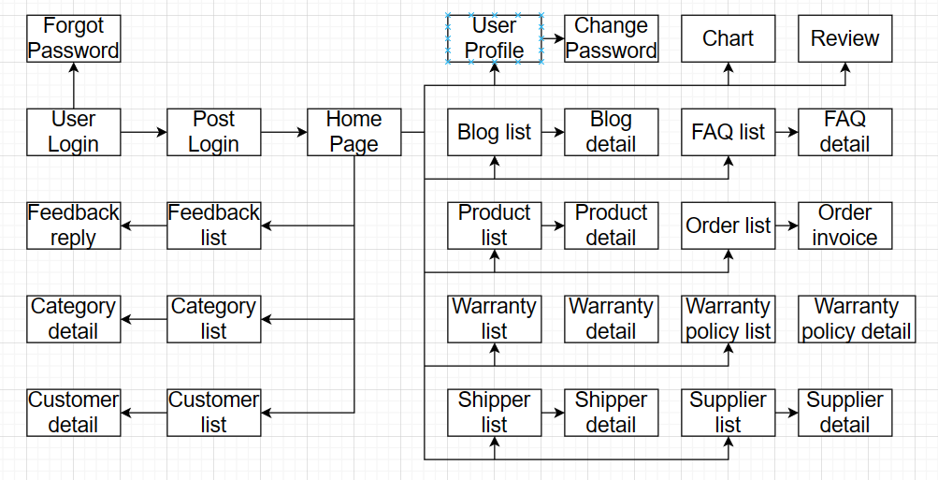

Figure 3.1.1 Screen flow admin

##### a.2 Customer

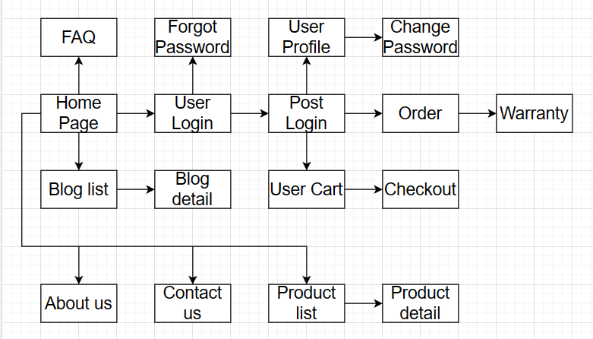

Figure 3.1.2 Screen flow customer

#### b. Screen Details

##### b.1 Customer

|  |  |  |  |
| --- | --- | --- | --- |
| # | Feature | Screen | Description |
| 1 | Authenticate & Authorize | Login | Login into the system by mail and password |
| 2 | Common Register | Fill out the necessary information to complete registration form |
| 3 | Forgot password | Input email to proceed reset password |
| 4 | Input OTP | Input OTP (6 digits) that is sent to the given email |
| 5 | Reset password | Input new password |
| 6 | Change password | Change current password |
| 7 | User Profile | View my profile | View detail information of the admin |
| 8 | Edit profile | Edit personal information |
| 9 | View Product | Search Product | Search for a tutorbased on name/category/Supplier/Price….. |
| 10 | Reivew Product | Customer can review product |
| 11 | Send feedback | Send feedback | Send feedback to administrator services, account, website…. |
| 12 | View Blog | Search Blog | Search for blog based on month, type blog…. |
| 13 | View Detail Blog | Read detail of blog |
| 14 | View all comment of blog |
| 15 | Customer can comment to blog |
| 16 | View FAQ | FAQ | View all faq of website |
| 17 | OrderManagement | View all order | Users can view all their orders |
| 18 | View order detail | Customers can view order details they have placed |
| 19 | cancel order | Customer can cancel order while it is in process state |
| 20 | Payment Order | Users can pay for their order if they want |
| 21 | Create order | Users can create orders with the products they want to buy in the shopping cart. But before that they have to login |
| 22 | Check order status | Customers can check the status of orders they have placed |
| 23 | Warranty | View time Warranty product | See the warranty period |
| 24 | Product warranty | Customers can send a product warranty claim form to admin to schedule a date to bring the product to check. Before that, the product must have a warranty period |
| 25 | Shopping Cart | Shopping cart | Customers can add, delete products to the cart. But before that they have to login |
| 26 | View Cart | Customers can view all products in the cart and request checkout |

##### b.2 Admin

|  |  |  |  |
| --- | --- | --- | --- |
| # | Feature | Screen | Description |
| 1 | Authenticate & Authorize | Login | Login into the system by mail and password |
| 2 | Choose a role to register | Choose the role to continue register a new account: Tutor/ Student |
| 3 | Common Register | Fill out necessary information to complete registration form |
| 4 | Forgot password | Input email to proceed reset password |
| 5 | Input OTP | Input OTP (6 digits) that is sent to the given email |
| 6 | Reset password | Input new password |
| 7 | Change password | Change current password |
| 8 | User Profile | View my profile | View detail information of the student |
| 9 | View customer profile | View detail information of the customer |
| 10 | Edit profile | Edit my information |
| 11 | Upload avatar | Change profile picture |
| 12 | Lock Customer Account | Lock account of customer. After lock account customer can’t login to system. There is an email sent to customers to notify |
| 13 | Unlock Customer Account | Unlock account of customer. After unlock account customer can login to system. There is an email sent to customers to notify |
| 14 | Discount | Create Discount | Admin can add a new discount and specify which products are discounted |
| 15 | Update Discount | Admin has updated 1 discount and updated which products are discounted |
| 16 | Delete Discount | Admin can edit the active status of that discount and all products with a discount with an active status of false will be set to the default discount of 0% |
| 17 |  | View Discount | Admin can see all existing discount list |
| 18 | Order Management | View order | Admin can see all customer orders |
| 19 | View order detail | Admin can see customer order details |
| 20 | Update order status | admin can update order status according to different status |
| 21 | Blog Management | View blog | Admin can view existing blogs |
| 22 | Update blog | Admin can update existing blogs |
| 23 | Delete Blog | Admin can delete existing blogs |
| 24 | Review Product Management | View review product | Admin can view all review of product |
| 25 | Hidden review | Admin can hidden review of product for customer. Have notification to customer |
| 26 | Warranty Management | View all warranty request | Admin can view all warranty claims from customers and make appointments for customers |
| 27 | Update warranty | Admin can update customer warranties and process them based on recorded product status |
| 28 | Feedback management | View all feedback | Admin can view all feedback from customer and guest |
| 29 | Reply feedback | Admin can respond to customer or customer feedback. Have notification to email |
| 30 | Shippment Management | View shipment | Admin can view all shipments |
| 31 | View profile shipment | Admin can view profile of shipment. And analyst of shipment |
| 32 | Update profile of shipment | Admin can update profile of shipment or change status of shipment |
| 33 | Add new shipment | Admin can add new shipment and check all information exist before add |
| 34 | Supplier Management | View Supplier | Admin can view all Suppliers |
| 35 | View profile Supplier | Admin can view profile of Supplier |
| 36 | Update profile of Supplier | Admin can update profile of Supplier or change status of Supplier |
| 37 |  | Add new supplier | Admin can add new supplier |
| 38 | Product management | View product | Admin can view all products exist |
| 39 | Update product | Admin can update product or change status of product. Cannot delete product |
| 40 | Add new product | Admin can add new product |
| 41 | Category Management | View all category | Admin can view all categories |
| 42 | Update category | Admin can update category |
| 43 | FAQ Management | View all FAQ | Admin can view all FAQs existing |
| 44 | Update FAQ | Admin can update Faq: question, answer |
| 45 | Delete FAQ | Admin can delete faq |
| 46 | Warranty policy Management | View all Warranty policy | Admin can view all Warranty policy |
| 47 | Update Warranty policy | Admin can update Warranty policy |

##### b.3 Guest

|  |  |  |  |
| --- | --- | --- | --- |
| **#** | **Feature** | **Screen** | **Description** |
| 1 | View product | Search product | Search for product based on name/category/price/supplier….. |
| 2 | View top product sale | View the current top 10 products of the system, based discount. |
| 3 | Product Detail | View review list of a product |
| 4 | Send feedback | Send feedback | Send feedback to administrator services, account, website…. |
| 5 | View Blog | Search Blog | Search for blog based on month, type blog…. |
| View Detail Blog | Read detail of blog |
| View all comment of blog |
| 6 | View FAQ | FAQ | View all faq of website |
| 7 | Register | Register | Guests can register for an account |

#### c. Screen Authorization

|  |  |  |  |  |
| --- | --- | --- | --- | --- |
| **#** | **Screen** | **Customer** | **Administrator** | **Guest** |
| 1 | Register Account | X |  | X |
| 2 | Login Account | X | X |  |
| 3 | Forgot Password | X | X |  |
| 4 | Reset Password | X | X |  |
| 5 | Enter OTP | X | X |  |
| 6 | Change Password | X | X |  |
| 7 | View Profile | X | X |  |
| 8 | Update Profile | X | X |  |
| 9 | Change Avatar | X | X |  |
| 10 | Search Product | X | X | X |
| 11 | View lastest Order | X | X |  |
| 12 | View all Order | X | X |  |
| 13 | Create new Order | X |  |  |
| 14 | View on-going Order | X | X |  |
| 15 | View complete Order | X | X |  |
| 16 | Cancel Order | X | X |  |
| 17 | View all request Order |  | X |  |
| 18 | View Review for Product | X | X | X |
| 19 | Review Product | X |  |  |
| 20 | Hide/unhide Review |  | X |  |
| 21 | Create Feedback | X |  | X |
| 22 | Reply Feedback |  | X |  |
| 23 | View Blog | X | X | X |
| 24 | Comment Blog | X |  |  |
| 25 | Create Blog |  | X |  |
| 26 | Update Blog |  | X |  |
| 27 | Delete Blog |  | X |  |
| 28 | View FAQ | X | X | X |
| 29 | Create FAQ |  | X |  |
| 30 | Update FAQ |  | X |  |
| 31 | Delete FAQ |  | X |  |
| 32 | Create Product |  | X |  |
| 33 | Update Product |  | X |  |
| 34 | Delete Product |  | X |  |
| 35 | Checkout | X |  |  |
| 36 | Create Category |  | X |  |
| 37 | Update Category |  | X |  |
| 38 | Delete Category |  | X |  |
| 39 | View Category | X | X | X |
| 40 | View Accounts list |  | X |  |
| 41 | View Account profile |  | X |  |
| 42 | View Shipper List |  | X |  |
| 43 | View Shipper Profile |  | X |  |
| 44 | Create Shipper |  | X |  |
| 45 | Update Shipper |  | X |  |
| 46 | Delete Shipper |  | X |  |
| 47 | View Supplier List |  | X |  |
| 48 | View Supplier Profile |  | X |  |
| 49 | Create Supplier |  | X |  |
| 50 | Update Supplier |  | X |  |
| 51 | Delete Supplier |  | X |  |
| 52 | View Warranty from Order | X |  |  |
| 53 | View Warranty list |  | X |  |
| 54 | Register to Warranty | X |  |  |
| 55 | Create Warranty |  | X |  |
| 56 | Update Warranty |  | X |  |
| 57 | Delete Warranty |  | X |  |
| 58 | View Warranty Policy for Product | X |  |  |
| 59 | View Warranty Policy list |  | X |  |
| 60 | Create Warranty Policy |  | X |  |
| 61 | Update Warranty Policy |  | X |  |
| 62 | View Cart | X |  |  |
| 63 | Update Cart | X |  |  |

#### d. Non-Screen Functions

|  |  |  |  |
| --- | --- | --- | --- |
| **#** | **Feature** | **System Function** | **Description** |
| 1 | Password encryption | Password encryption | Passwords are encrypted in database so as to prevent exploitation |
| 2 | Forgot password | OTP verification | Use OTP code to allow users to change password in case of forgetting |
| 3 | Google login | Google login | Allow users to log in with Google Account conveniently |
| 4 | VNPay checkout | VNPay API | Allow users to purchase using VNPay |

#### e. Entity Relationship Diagram

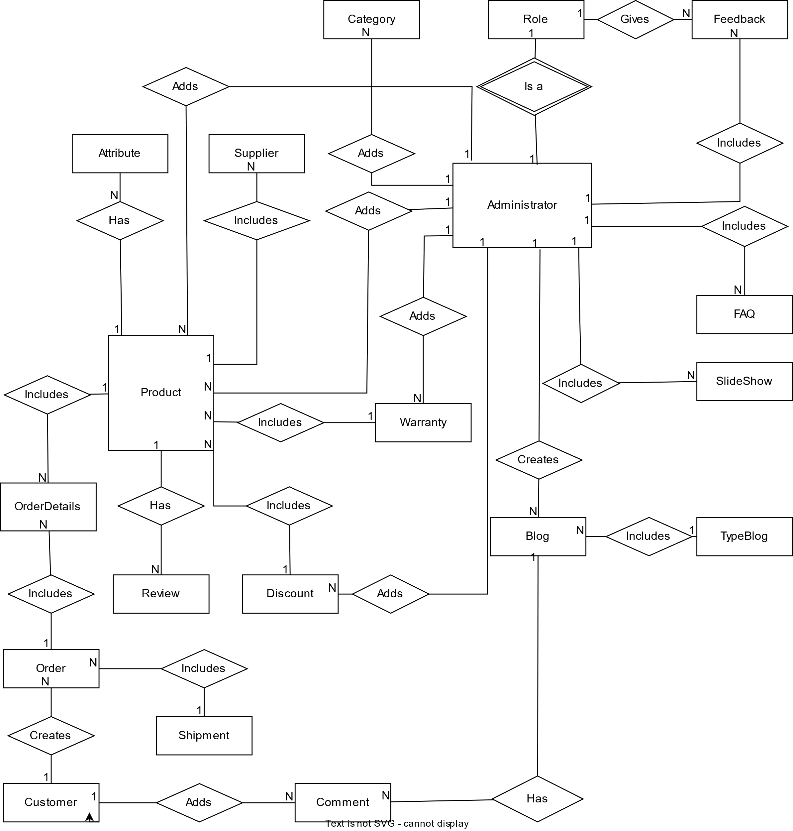

**Entities List**

|  |  |  |
| --- | --- | --- |
| **#** | **Entity** | **Description** |
| 1 | Role | Stores the users’ role of the web application. |
| 2 | Feedback | Stores the feedback of the customer |
| 3 | Category | Stores the categories of the products |
| 4 | Attribute | Stores attributes of the products |
| 5 | Supplier | Stores the suppliers’ information of the products |
| 6 | Product | Stores products’ information |
| 7 | Warranty | Stores warranty policies |
| 8 | Discount | Stores the discount information |
| 9 | Comment | Stores the comments on blogs |
| 10 | Blog | Stores blogs of the web application |
| 11 | Customer | Stores customers’ information, who has registered |
| 12 | Review | Stores the reviews of customers on the product |
| 13 | TypeBlog | Stores different type of blogs |
| 14 | Order | Stores information related to orders |
| 15 | OrderDetails | Stores details of each product in orders |
| 16 | Shipments | Stores shipments information |
| 17 | Administrator | Stores administrators’ information |
| 18 | FAQ | Stores FAQ |
| 19 | SlideShow | Stores the images for slideshow |

## 4. Non-Functional Requirements

### 4.1 External Interfaces

#### a. Hardware Interfaces

No hardware interfaces have been identified.

#### b. User Interfaces

UI-1: The websites will have a user-friendly interface and are easy to use.

UI-2: The layout of the screen is streamlined, easy to operate, and implement for the user.

UI-3: Buttons have distinctive features and colours but are in sync with the interface.

UI-4: When the user is on a screen or function, the position of that function displayed on the sidebar will be bright and synchronized with the interface.

UI-5: Notifications displayed on the screen have a friendly banner outlining the content for the user.

UI-6: Web pages will allow users to copy and paste using a mouse, in addition to using a mouse and keyboard combination.

#### c. Software Interface

SI-1:VNPay sandbox

#### d. Comunication Interface

CI-1: The web browser will automatically log out if the user does not use the system within 30 seconds.

CI-2: The system shall send an email when prompted or when it is needed to remind the customer.

### 4.2 Quality Attributes

#### a. Avaibility

AVL-1: The site is always up and running 90%

#### b. Security

The MVC model provides a structure that can support security measures in an application. Here are key security characteristics for each component:

* Model: Encapsulation, input validation, authentication, and authorization.
* View: Output encoding, access control.
* Controller: Request validation, CSRF protection, security headers.
* However, it's essential to implement additional security measures like encryption, secure coding practices, and regular audits for a robust security architecture.

### 5.1 Appendix1 - Messages List

|  |  |  |  |  |
| --- | --- | --- | --- | --- |
| **#** | **Message code** | **Message Type** | **Context** | **Content** |
| 1 | MSG01 | In line | There is not any search result | *No search result.* |
| 2 | MSG02 | In red, under the text box | Input-required fields are empty | *The * field is required.* |
| 3 | MSG03 | Toast message | Updating asset(s) information successfully | *Update asset(s) successfully.* |
| 4 | MSG04 | Toast message | Adding new asset successfully | *Add asset successfully.* |
| 5 | MSG05 | Toast message | Confirming email of asset hand-over is sent successfully | *A confirmation email has been sent to {email_address}.* |
| 6 | MSG06 | Toast message | Resetting asset information successfully | *Return asset(s) successfully.* |
| 7 | MSG07 | Toast message | Deleting asset information successfully | *Delete asset(s) successfully.* |
| 8 | MSG08 | In red, under the text box | Input value length > max length | *Exceed max length of {max_length}.* |
| 9 | MSG09 | In line | Username or password is not correct when clicking sign-in | *Incorrrect user name or password. Please check again.* |

### 5.2 Appendix2 - …

### 5.3 …